Name and Credentials | Signature | Initials
Dr. John Doe, M.D. | 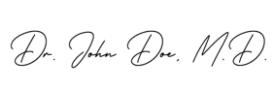 | 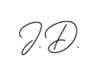
Dr. Jane Roe, M.D. | 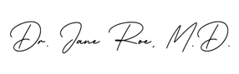 | 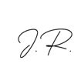
Dr. Ivan Ho, D.O. | 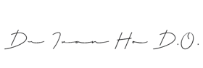 | 